K-4 Book List

Abeka Numbers Writing Tablet K5

ASIN : B00IX6Y2Z2
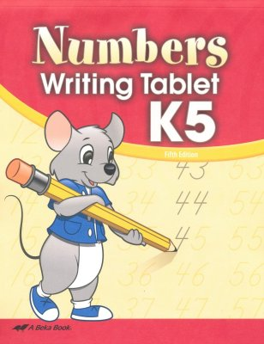

K4 Child Kit Manuscript - Abeka 4 Year Old Phonics,
Reading, Manuscript Writing, Numbers Student Work Book
B07RMK858C
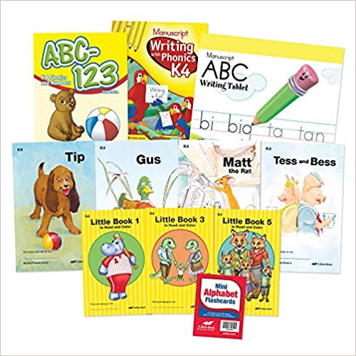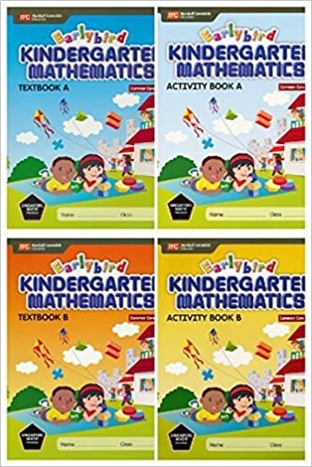 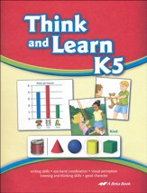Abeka
Earlybird Kindergarten Math Common Core Edition
ASIN : B078KRG97V
2nd grade Book List
Saxon Math, Intermediate Grade 3 Textbook #9781600325342
Saxon Math Power-up workbook: Intermediate Grade 3 1st edition #9781600325106

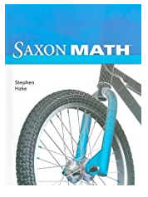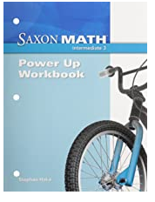

Science: A closer look Grade 3 Building Skills Reading and Writing #9780022840730/Textbook: #9780022841362
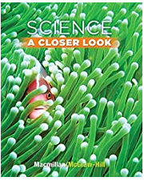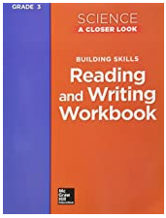

Social Studies (Harcourt Brace)
Textbook:9780153858840/ Workbook:#9780153472947

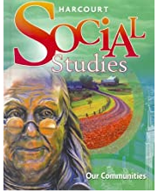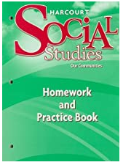

Language Arts 3rd grade Workbook/Textbook #978002244652
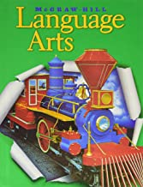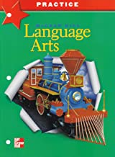
Wonders Literature Anthology Grade 3: #9780021341740/
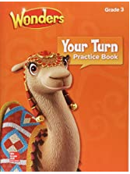
Wonders My Turn Reading Practice Book: #9780076774678
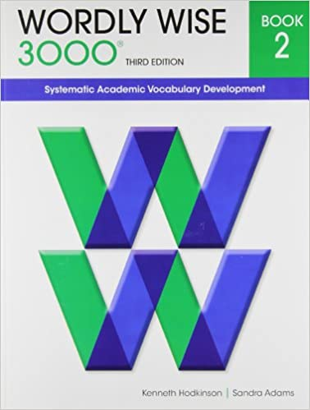 Wordly Wise 3000 Book 2-978-0838876022

Kindergarten Book List

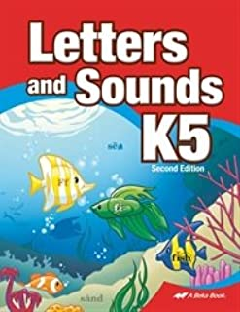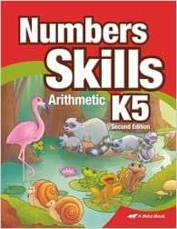

Letters and Sounds K5 - Abeka 5 Year Old Alphabet Recognition Reading Program Student Work Book ASIN : B07C84PDDQ / Numbers Skills K5 Paperback- B07C86J4F3

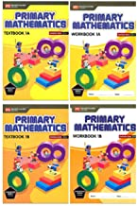 Language Arts Grade 1
978-0022446499

Singapore Math Primary Mathematics Grade 1 Set (4 Books) Common Core Edition

# B06ZYJFK3L

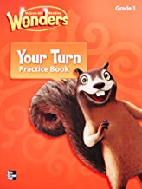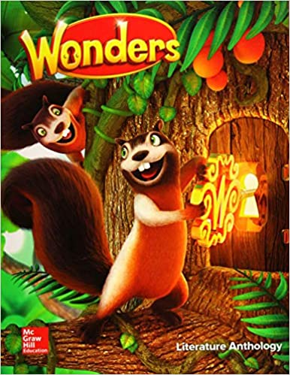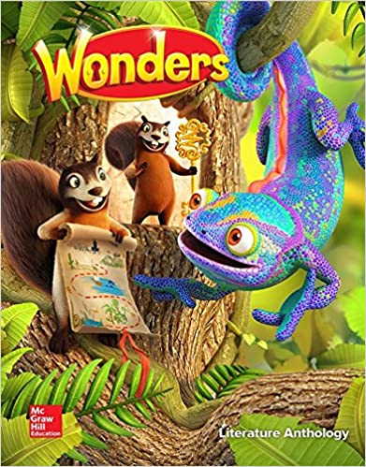
Volume 1 Volume 2
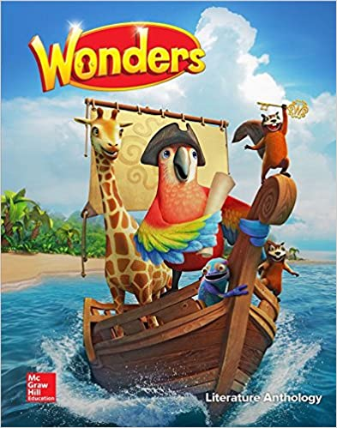
Volume 3 Volume 4
Wonders Reading Book Series/ Your Turn Practice Book 978-0021195329

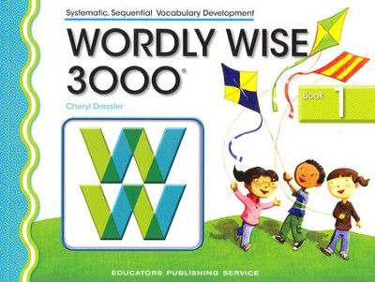 Wordly Wise 3000 Book 1 9780838828199

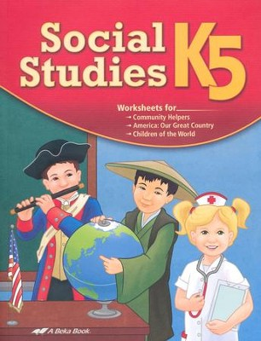 Abeka Social Studies, New Edition--Grade K5# WW200889

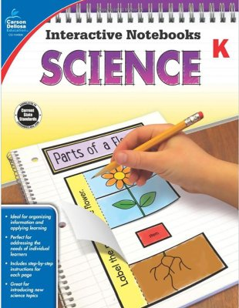 Interactive Notebooks Science, Grade K # WW831206

1st Grade Book List

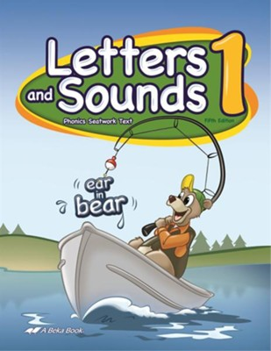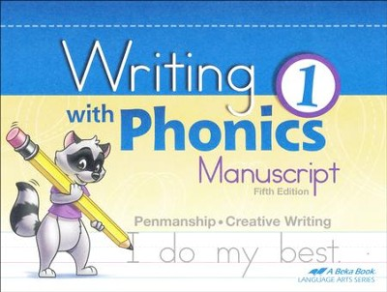

Abeka Letters and Sounds 1-# 95125008 Abeka Writing With Phonics 1- #13986

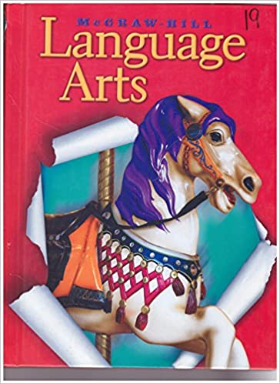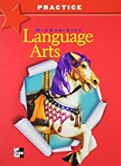

Language Arts Textbook #97880022454470/Practice Book #002244718

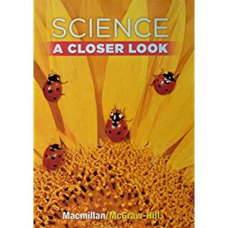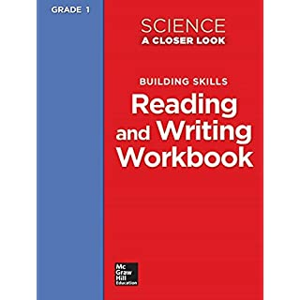

Science Grade 1: A Closer Look Hardcover- 978-0022841348/ Practice Book 978-0022840716

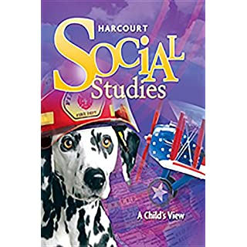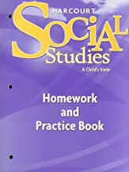

Harcourt Social Studies: Student Edition Grade 1 978-0153858826/Harcourt Social Studies: Homework and Practice Book Student Edition Grade 1978-0153472923

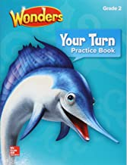

Reading Wonders Anthology Grade 2 #978800212340989/ Your Turn Practice Book # 9780076807215

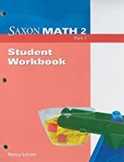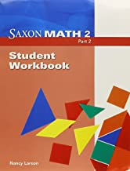

Saxon Math Intermediate 2 Student Unit Workbook 1&2-#9781600327216

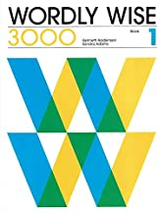Wordly Wise Book 1- 978-0838824313

3rd Grade Book List

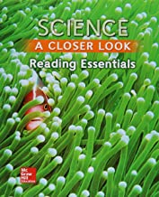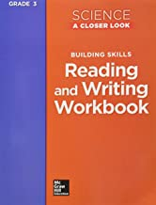

Science, A Closer Look, Grade 3, #978-0022881542/ Workbook- #978-0022840730

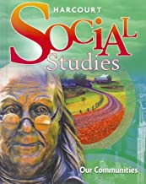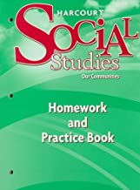
Harcourt Social Studies “Our Communities”=# 978-0153858840/ Practice Book-#978-0153472947
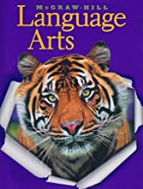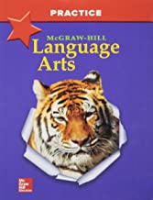
McGraw Hill Language Arts Grade 4-#978-0022446536/ Practice Book-# 978-0022447168

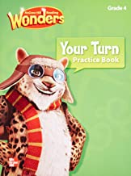
Wonders Literature Anthology Grade 4
Textbook#97880021417377/ Your Turn Practice #97880076785131
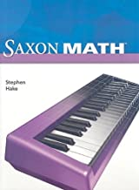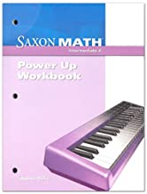
Saxon Math Intermediate Grade 4 #978-1600325403/ Power Up Book #978-1600325137

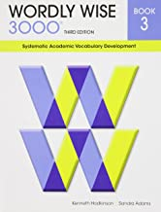Wordly Wise 3000 : Systematic Academic Vocabulary Development, Book 3-9780838876039

4th Grade Book List
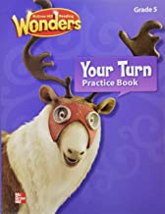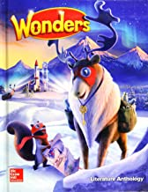
Wonders Literature Anthology Grade 5 Reading Text #9780021417872/ Your Turn Practice Book #97880076779246
Social Studies
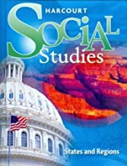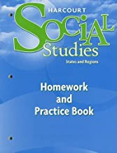
Harcourt Social Studies Student Edition Grade 4 (States and Regions)-9780153858864/ Practice Book #978053472954
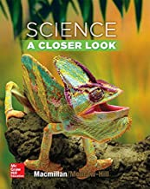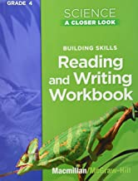 Science: A Closer Look Grade 4 Student Edition Textbook-#0022841377/ Practice Book #002284075
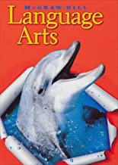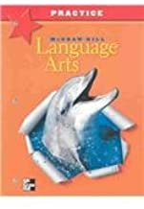
McGraw Hill Language Arts Textbook: 978-0022446543/ Practice Book #9780022447175
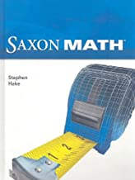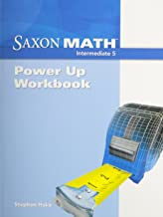
Saxon Math Grade 5 Textbook #9781600325465/ Power Up Book #9781600325175

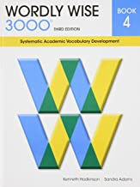Wordly Wise 3000 Book 4: Systematic Academic Vocabulary Development-978-0838876046

5th Grade Book List
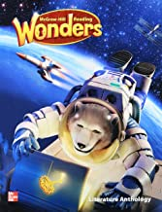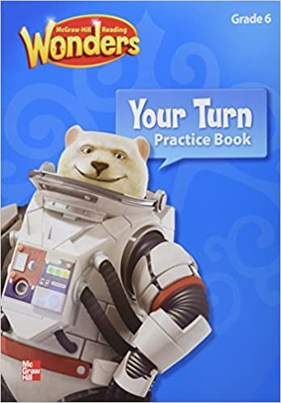
Reading Wonders Grade 6 #9780021187126/ Your Turn Practice #9780021187133
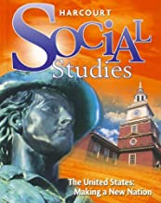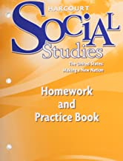
Harcourt Social Studies: Making A New Nation #978-0022841386/ Practice Book #978-0022840754
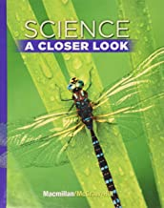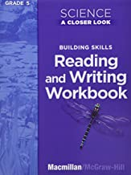
Science A Closer Look Grade 5: 978-0022880095/ Practice Books #978-0022840754
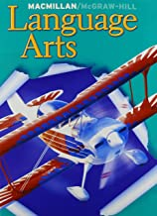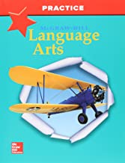
McGraw Hill Language Arts 978-0022455644/ Practice Book #978-0022447182
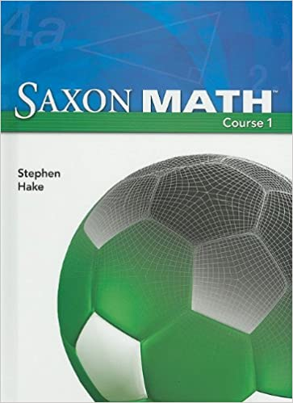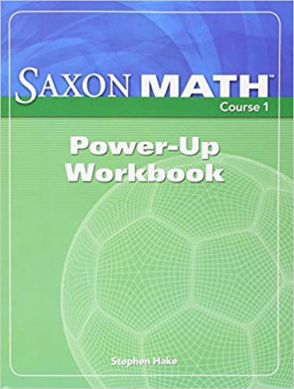
Saxon Math Intermediate 6 Text Book- 9781591417835 Power Up Book-978-1591418238

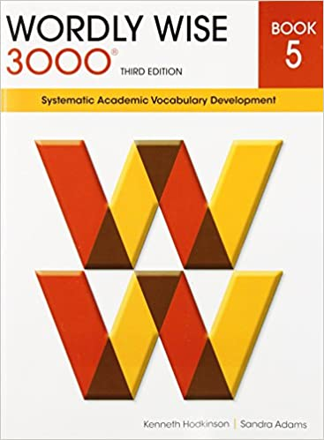Wordly Wise 3000 Book 5: Systematic Academic Vocabulary Development-978-0838876053

