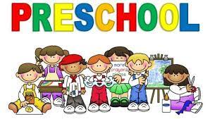
K-4 School Supply List
- Koala Tools/ Bear Claw Pencils- Fat
- Stylo Pencil Grips For Kids Handwriting
- Pacon Multi- Sensory Raised Ruled Tablet
- Child soft grip cutting scissors
- School Supply Box
- Washable Crayons
- Glue sticks
- Math Link Cubes
- Washable Markers
- Dry Erase Board/ Lap Board
- Low Odor Dry Erase Board
- Lysol Wipes
- Kleenex Tissue
- Pocket Folders
- Refillable Water bottle
- Large Backpack
- Coloring Book

